(Approx. 528 words)

Review: MailWasher Pro
Another Level of Protection
Author: Jim Fromm, Editor/Webmaster, MOAA-The TUG, HI
October 2019 issue, The TUG newsletter
www.the-tug.org
editor (at) the-tug.org

Our September meeting was mostly Q&A; one of the questions received via email was about MailWasher Pro. I am going to save some keyboard clicks and refer to it as MWP. It is a utility that lets you look at the headers of all the emails in all of your mailboxes before downloading. It is very useful if you have multiple mailboxes. I have 12 email addresses, (don’t ask), and eliminates the ads, solicitations, requests from Amazon for reviews, etc. before they ever make it into my mail program. Besides saving space, it decreases the chance of getting bit by malware. Here’s a portion of the opening screen.
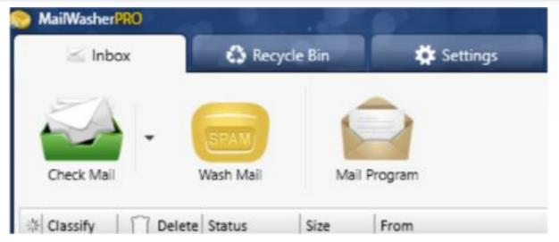
You have three immediate choices. Check for new mail, Wash (delete) mail and Select the mail program you want to use. Messages are listed in order received (default) or you can click on the title bar to separate them to your liking. Clicking on the box in the Delete column will select those emails for deletion. When you’ve finished picking the ones you don’t want, click on the bar of soap icon. They will be deleted from the listing—but—like a bad penny, they are not completely gone. The messages are moved to the Recycle bin and will remain there until you clean it out.

If you want to recover one, or more, or those in the Recycle bin, merely right click on the email and select Restore. You’ll need to have designated an email address to send them to. They will be sent to that address and show up in MWP again.

After you’ve decided which ones go and which ones stay, click on Mail Program. Your designated mail program will launch and download the mail into their respective Inboxes.

- If you’ve signed up for a number of ezines that you no longer want and have been unable to unsubscribe, click the box in the delete column.
- If you receive emails urging you to verify your subscription, for which you’ve never signed up for, click the box.
- If you get email from companies offering you discounts on products that you’re never going to buy, click the box.

Simple as that.

You can mark messages as spam and block them via sender, and even domain.

Avoid viruses, spam, junk mail and other pesky emails with MWP. Works with all email programs. I use Outlook 2019. Set-up is easy; MWP will import the settings for your existing email accounts.

Now, here comes the part that will turn some of you penny pinchers off. MWP is not free. The initial one-year subscription costs $29.96 and can be used on three computers, including your mobile devices. Renewals are $24.95 per year, three computers. I just renewed with a 2-year renewal for $43.16. I’ve been using MWP since version 1, they are now into version 7.

Hooray!!, there is a free 30-day trial version. You can use it with full functionality for 30 days and then, subscribe or take your chances and do without it.

Travel to https://www.firetrust.com/products/mailwasher-pro# to get the trial version or pay to help the authors.

